**Department 1**

**Department of University Development and Strategy**

Gebäude UV 3/360

Universitätsstraße 150, 44801 Bochum

**Jonna Tikkanen**

Fon +49 (0)234 32- 29627

Jonna.tikkanen@rub.de

**ERASMUS+ INTERNSHIP AT THE RUHR UNIVERSITY BOCHUM,**

**GERMANY/UNIC TEAM**

**ONE POSITION AVAILABLE**

(2,5-3 months; full-time)

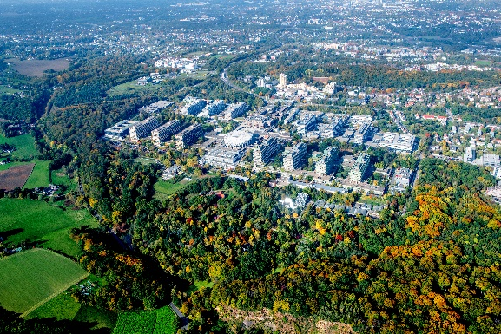Located in the heart of Europe in the dynamic metropolitan region of the “Ruhrgebiet”, Ruhr University Bochum with its 21 faculties is home to about 40,000 students and driving force of social change.

RUB is part of the international university consortium UNIC – European University of Cities in Post-Industrial Transition. UNIC is an association of ten universities dedicated to promoting student virtual and on-site mobility, inclusion, superdiversity and engaged research in an international context.

© RUB, Marquard

The RUB UNIC coordination office is located at our university’s central administration in the department of “university development”, on the RUB main campus.

**About the vacancy**

The RUB UNIC team offers you the opportunity to join them as a full-time intern. The focus of the internship will be set on communication, organisation and documentation tasks.

***Tasks and responsibilities***

The intern will

* organise meetings with involved stakeholders: prepare agendas, contact participants, draft minutes/reports etc.,
* assist with the project reporting,
* assist with the logistics of the organisation of project events,
* support with the documentation of best practice cases and processes and
* support communication and dissemination activities (webpage, social media)

This is not an exhaustive list and the tasks may vary depending on the circumstances.

**Practical Details**

* The internship takes place in Bochum, Germany, for a period of 2,5 to 3 months.
* The internship can start between September 1st and October 15th 2024, depending on your availabilities.
* Full working week; 5 days per week.
* The intern needs to apply for a funding grant such as the Erasmus + mobility grant from her/his own local university.

**Qualifications Required**

* Student of one of the UNIC universities
* Student enrolled in Bachelor’s or Master’s programme
* Good writing and communication skills in English (minimum C1 level)
* Interest in and experience with social media (e.g., X, Instagram)
* Interest in administrative and regulatory details of higher education
* Proactive, responsible and able to work independently

**Interested? Please send your application composed of:**

* Curriculum Vitae (max. 2 pages)
* Motivation Letter (max. 1 page)
* Proof of enrolment

before May 31st , 2024 to: jonna.tikkanen@rub.de

Selected candidates will be invited to an online interview.